**MIDDLE EAST TECHNICAL UNIVERSITY**

**DEPARTMENT OF ELECTRICAL & ELECTRONICS ENGINEERING**



**TROY TECH**

**WEEKLY REPORT #8**

**28.11.2018-07.12.2018**

**Section :** 7

**Studio Coordinator:** Mustafa Mert ANKARALI

**Partners :**

Hasan ÖZKARA - 2031888

Kağan ÖZASLAN - 2031854

Caner POTUR - 2031250

Mustafa Ercan OKATAN - 2031193

Mert KAYIŞ – 2030997

**Progresses for Previous Week:**

* We have tested FPV camera and receiver module. We could transmit the video from the entrance of E building to the canteen in D building successfully.
* We have tested both NRF24L01+ and APC220 modules for wireless command transmission. We could transfer the commands from the entrance of E building to the main entrance of D building.
* We searched about different shooting techniques.
* We worked on sensing the buttons of PlayStation 1 Joystick. An example test about reading the analogs (LEFT_X, LEFT_Y, RIGHT_X, RIGHT_Y) is given in Fig. 1.

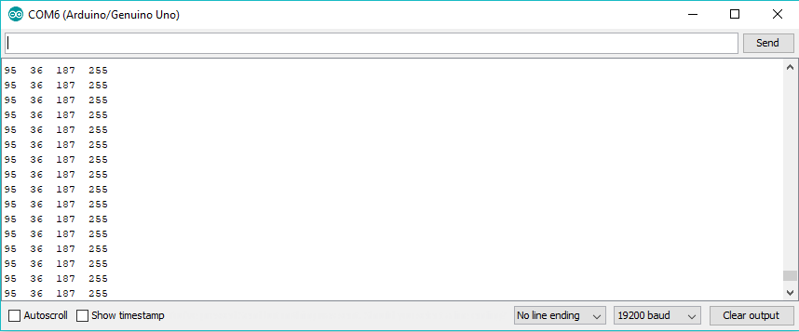

Figure 1 Reading analogs from PS1 Joystick

* We worked on encoder to detect motor speed. Some tests for reading encoder value and reading current speed are given in Fig. 2 and Fig. 3

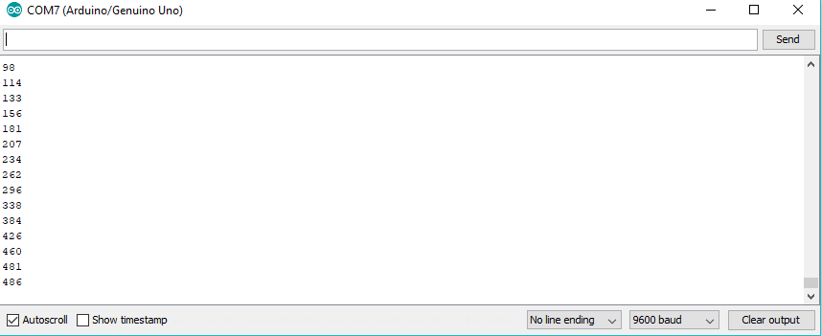

Figure 2 Reading encoder value

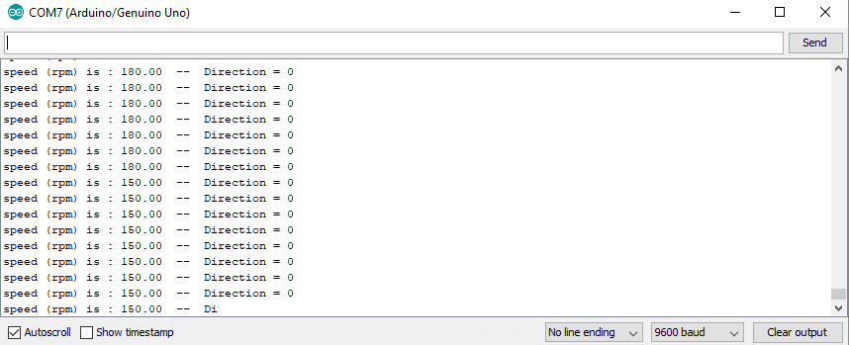

Figure 3 Detecting speed from encoder value

**Plans for the Next Week:**

* Increasing the range of wireless command transfer by trying different antennas or different modules.
* Driving the motor using PI/PID controller.
* Uniting PS1 joystick and command transfer modules.
* Discussing about test results.